DEPARTMENT OF COMPUTER SCIENCE


Msc data Science - Semester 1

Data visualization for data science.
Journal
2025-2026
Submitted by -
Manish Prajapati
Seat no-251048

Certifiacte.

To clarify that work is entered in this journal was done in the university of mumbai department of computer science laboratory by mr Manish prajapati seat no 251048 for the course of msc in data science NEP semester 1 during the acadmic year 2025- 2026 in a statisfactory manner.

Subject in-charge head of department
_____________________ _________________

External examiner
__________________

index
Serial No | Practical | No | Date | Sign
1 | Implement Data Loading, Storage and File Formats. Read data and store them in text format. operations. | 01 | 16/08/2025
2 | Implement the code to interact with Web APIs and to perform web scrapping. | 03 | 23/08/2025
3 | Demonstrate Data Cleaning and Preparation. | 05 | 07/09/2025
4 | Implement Data wrangling on a data set. | 10 | 14/09/2025
5 | Demonstrate the handling of missing data and string manipulation | 17 | 21/09/2025
6 | Create common charts with title, labels and descriptions using Tableau | 21 | 28/09/2025
7 | Perform sorting and filtering using tableau, create visualizations and publish it on Tableau Cloud. | 23 | 12/10/2025
8 | Perform data visualization using Power BI. | 27 | 19/10/2025
9 | Create reports using Power BI. | 31 | 02/11/2025
10 | Create a data story in Tableau or power BI. | 34 | 08/11/2025

Pracatical no -01
Title:- Implement Data Loading, Storage and File Formats. Read data and store them in text format. operations.
Aim:- To load data into a Business Intelligence tool (Tableau), understand different file formats, and perform basic data operations and visualization
Objetive:-
- To understand data loading in BI tools
- To study text-based file formats (TXT, CSV)
- To load dataset into Tableau
- To perform basic operations and visualization

Explanation:-
Data loading refers to importing data from external sources such as text files or CSV files into a BI tool for analysis.
CSV File (.csv): Comma separated values, structured and widely used in analytics Tool:-
power bi is a data visualization and tableau tool used to analyze data and create interactive dashboards.

Dataset description:-
A sample dataset stored in CSV / text format containing fields such as
[category ,salse, profit, region]
sales_data.txt
Category,Sales,Profit,Region
Furniture,25000,4000,East
Technology,45000,8000,West
Office Supplies,15000,,South
Furniture,30000,5000,East
Technology,40000,7500,North

Process and steps:-
- Load data into Tableau
- Verify rows and columns in Data Source tab
- Open a new worksheet
- Drag Dimensions and Measures into Rows and Columns
- Apply basic operations such as filtering and sorting
- Create simple visualization (Bar Chart)
- Save the workbook

Code :-
1-Data loading:-
import pandas as pd

# Load data from text file
df = pd.read_csv("sales_data.txt", delimiter=",")

print("Loaded Data")
print(df)

output:-
Category Sales Profit Region
0 Furniture 25000 4000.0 East
1 Technology 45000 8000.0 West
2 Office Supplies 15000 NaN South
3 Furniture 30000 5000.0 East
4 Technology 40000 7500.0 North

2-Data processing:-
df['Profit'].fillna(df['Profit'].mean(), inplace=True)

print("\nAfter Handling Missing Profit")
print(df)

output:-
Category Sales Profit Region
0 Furniture 25000 4000.0 East
1 Technology 45000 8000.0 West
2 Office Supplies 15000 5625.0 South
3 Furniture 30000 5000.0 East
4 Technology 40000 7500.0 North

3-Data analysis:-
summary = df.groupby("Category")[["Sales", "Profit"]].sum()
print("\nCategory-wise Summary")
print(summary)

output:-
Sales Profit
Category
Furniture 55000 9000.0
Office Supplies 15000 5625.0
Technology 85000 15500.0

Result:- data loading, storage, and basic data operations using BI tool (Tableau) were successfully implemented.Bi and Tableau efficiently handle data loading from text-based file formats and help in analyzing and visualizing data for business insights.

Practical no-02
Title:- Implement the code to interact with Web APIs and to perform web scrapping.
Aim:- To study interaction with Web APIs and perform web scraping to collect data from websites for data analytics.
objective:- Web APIs allow applications to communicate with web services and retrieve data in formats such as JSON or XML. Web scraping is the technique of extracting information from websites. These methods are commonly used in data analytics for data collection.
Web API: A Web API provides structured access to data using beaeetifull soup URLs and HTTP requests.
Web Scraping: Web scraping involves collecting unstructured data from web pages and converting it into usable format

Process:-
- Identify data source (Web API / Website)
- Send request to API or webpage
- Receive response data
- Extract required information
- Store data for analysis
Operations Performed: Data collection ,Data extraction ,Data storage , Data preparation
Libraries Used: • BeautifulSoup (from bs4): For parsing HTML and XML documents. • requests: For sending HTTP requests and retrieving HTML content.
Dataset used: We have used the 'http://quotes.toscrape.com/' website to scrape the data. Along that we have also used the OpenWeatherMap API to scape weather information.
Code:-
import requests
from bs4 import BeautifulSoup
# Step 1: Send an HTTP request to the website
url = 'http://quotes.toscrape.com/'
response = requests.get(url)

# Check if the request was successful
if response.status_code == 200:
# Step 2: Parse the HTML content of the page with BeautifulSoup
soup = BeautifulSoup(response.text, 'html.parser')

# Step 3: Find all the quotes and authors
quotes_data = [] # To store the quotes and authors

# In the website, quotes are inside <span> tags with class 'text' and authors in <small> tags with class 'author'
quotes = soup.find_all('span', class_='text')
authors = soup.find_all('small', class_='author')

# Step 4: Loop through the quotes and authors, and store them in a dictionary
for i in range(len(quotes)):
quote_text = quotes[i].text
author = authors[i].text
quotes_data.append({'quote': quote_text, 'author': author})

# Step 5: Display the scraped data
for entry in quotes_data:
print(f"Quote: {entry['quote']}")
print(f"Author: {entry['author']}")
print('---')
else:
print(f"Failed to retrieve the webpage. Status code: {response.status_code}")

# Replace with your actual OpenWeatherMap API key
API_KEY='ff397c60609dbfd1e4df25ab1a6dddae'
city = 'mumbai' # Adding country code to avoid ambiguity
# Define the API endpoint and include your API key
url = f"http://api.openweathermap.org/data/2.5/weather?q={city}&appid={API_KEY}&units=metric"
# Send a GET request to the API
response = requests.get(url)

# Check if the request was successful
if response.status_code == 200:
data = response.json()
print(f"City: {data['name']}")
print(f"Temperature: {data['main']['temp']}°C")
print(f"Weather: {data['weather'][0]['description']}")
else:
print(f"Failed to retrieve data. Status code: {response.status_code}, Reason: {response.reason}")

output:-
City: Mumbai
Temperature: 25.99°C
Weather: moderate rain

Result:-
Data was successfully collected from web source and stored for further analysis.
Web API interaction and web scraping concepts were successfully implemented.
Web APIs and web scraping are important techniques for collecting real-time and online data for analytics.

Practical no -03
Title:- Web APIs and web scraping are important techniques for collecting real-time and online data for analytics
Aim:- To demonstrate data cleaning and preparation techniques used in data analytics to improve data quality.

Expanation:-
Data Cleaning and Preparation is the process of identifying and correcting errors in raw data. It helps in removing missing values, duplicate records, and inconsistent data so that the dataset becomes suitable for analysis.

Data Cleaning Techniques-
- Removing missing values
- Handling duplicate data
- Correcting incorrect data
- Standardizing data format
•

Data Preparation:-
Data preparation includes transforming cleaned data into a suitable format for analysis. It may include sorting, filtering, and formatting data.

Opration Performs:-
- Data cleaning
- Data formatting
- Data filtering
- Data preparation

Process & step:-
- Load the dataset into the tool
- Identify missing or incorrect values
- Remove or correct the errors
- Remove duplicate records
- Prepare data for analysis

Result:-
this dataset was successfully cleaned and prepared for further data analysis Data cleaning and preparation improve data quality and help in accurate data analysis.

practical no- 04
Title:- Implement Data wrangling on a data set.
Aim:- To implement data wrangling on a given dataset in order to clean, transform, and organize the data for analysis.

Explanation:-
Data wrangling is the process of cleaning, structuring, and transforming raw data into a usable format. It helps in handling missing values, correcting data types, and preparing data for analysis and visualization.
Data Wrangling steps:-
• Create DataFrame
• Check missing values
• Handle missing values
• Remove duplicates
• Fix data types
• Standardize text
• Final clean data
Action including this opration
- Data cleaning
- Data transformation
- Data filtering
- Data organizatio
Code:-
mport pandas as pd
import numpy as np

# Load Titanic dataset (CSV)
df = pd.read_csv("titanic.csv")

print("Original Dataset")
print(df.head())
print(df.info())
print(df.isnull().sum())
df.drop(columns=["Cabin", "PassengerId", "Name", "Ticket"], inplace=True, errors="ignore")

print(df.columns)
df["Age"].fillna(df["Age"].mean(), inplace=True)
df["Embarked"].fillna(df["Embarked"].mode()[0], inplace=True)
print(df.isnull().sum())
Data Type & Encoding (Categorical → Numeric)
df["Sex"] = df["Sex"].map({"male": 0, "female": 1})
df["Embarked"] = df["Embarked"].map({"S": 0, "C": 1, "Q": 2})
# Feature Engineering
df["FamilySize"] = df["SibSp"] + df["Parch"] + 1
#final and clean datasets
print("Cleaned Titanic Dataset")
print(df.head())

output:-

0 1 0 3 male 22.0 1 0 7.25 S
1 2 1 1 female 38.0 1 0 71.28 C
2 3 1 3 female 26.0 0 0 7.92 S
Mising value:-
Age 177
Embarked 2
Cabin 687
After clear mising values:-
urvived 0
Pclass 0
Sex 0
Age 0
SibSp 0
Parch 0
Fare 0
Embarked 0
Final output:-
Survived Pclass Sex Age SibSp Parch Fare Embarked FamilySize
0 0 3 0 22.0 1 0 7.25 0 2
1 1 1 1 38.0 1 0 71.28 1 2
2 1 3 1 26.0 0 0 7.92 0 1

Result:-
Data wrangling was successfully implemented and the dataset was prepared for analysis. Data wrangling improves data quality and ensures accurate and reliable data analysis

Prctical no 05

Title:- Demonstrate the handling of missing data and string manipulation
Aim:- To demonstrate the handling of missing data and perform string manipulation on a given dataset.

Explanation:-
Missing data refers to the absence of values in a dataset. Handling missing data is important to improve data quality and accuracy.
String manipulation involves modifying text data such as converting text to uppercase or lowercase, removing extra spaces, and correcting text formats.

Handling Missing Data Techniques
- Removing rows with missing values
- Replacing missing values with suitable values • Identifying null or blank entries

string manupulation:-
- Converting text to upper or lower case
- Removing extra spaces
- Renaming or correcting text values
- Standardizing text format

Opration:-
Missing value handling
Text formatting
Data cleaning
Data preparation

Process and steps:-
- Load the dataset into the analytics tool
- Identify missing or blank values
- Remove or replace missing values
- Select string/text column

Code:-
import pandas as pd
import numpy as np

data = {
"ID": [1, 2, 3, 4, 5],
"Name": ["Rahul", "Anita", "Suresh", "pooja", np.nan],
"City": ["Mumbai", "Delhi", np.nan, "Pune", "Mumbai"],
"Email": ["rahul@gmail.com", np.nan, "suresh@gmail.com", "pooja@yahoo.com", np.nan],
"Salary": [50000, 60000, np.nan, 55000, 58000]
}

df = pd.DataFrame(data)
print("Original Data")
print(df)
#detect mising value
print(df.isnull())
# fill mising value with mean
df["Salary"].fillna(df["Salary"].mean(), inplace=True)
print("After Handling Missing Data")
print(df)
#string manupulation
df["Name"] = df["Name"].str.title()

output:-
fresh data
ID Name City Email Salary
0 1 Rahul Mumbai rahul@gmail.com 50000.0
1 2 Anita Delhi NaN 60000.0
2 3 Suresh NaN suresh@gmail.com NaN
3 4 pooja Pune pooja@yahoo.com 55000.0
4 5 NaN Mumbai NaN 58000.0

# after cleaning mising values
ID Name City Email Salary
0 1 Rahul Mumbai rahul@gmail.com 50000.0
1 2 Anita Delhi not_provided 60000.0
2 3 Suresh Mumbai suresh@gmail.com 55750.0
3 4 pooja Pune pooja@yahoo.com 55000.0
4 5 Unknown Mumbai not_provided 58000.0

Result:-
Missing data was handled successfully and string values were properly formatted Handling missing data and string manipulation improves data consistency and accuracy for data analysis.

Practical no- 06
Title:- Create common charts with title, labels and descriptions using Tableau.
Aim:- To create common charts such as bar chart, line chart, and pie chart with proper title, labels, and descriptions using Tableau.

Explanation:-
Data visualization helps in understanding data through graphical representation. Tableau is a BI tool that allows users to create interactive charts and add titles, labels, and descriptions for better interpretation of data.

common Charts in Tableau:-
• Bar Chart

• Line Chart •

Pie Chart

oprations Performed-
- Data visualization
- Chart creation
- Adding titles and labels
- Data interpretation

Process & step:-
- Open Tableau Desktop
- Connect to the dataset
- Load data into Tableau
- Open a new worksheet
- Drag dimensions to Columns
- Drag measures to Rows
- Select chart type (Bar / Line / Pie)
- Add chart title
- Enable data labels
- Add description or annotations
- Save the worksheet
Bar chart:-
a. Open Tableau and connect to your data source.
b. Drag the dimension you want to represent on the x-axis to Columns.
c. Drag the measure you want to represent on the y-axis to Rows.
d. Tableau will automatically create a bar chart.
e. Customize the chart by adding titles, labels, and descriptions in the "Titles" and "Annotations" sections.
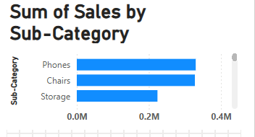
Line chart:-
a. Follow steps 1-3 from the Bar Chart instructions.
b. Instead of a bar chart, Tableau will create a line chart.
c. You can customize the chart in the same way as the Bar Chart, adding titles, labels, and
descriptions

pie chart:-
a. Follow steps 1-3 from the Bar Chart instructions.
b. Drag the dimension you want to represent on the pie slices to the "Color" shelf.
c. Tableau will automatically create a pie chart.
d. Customize the chart as needed, adding titles, labels, and descriptions
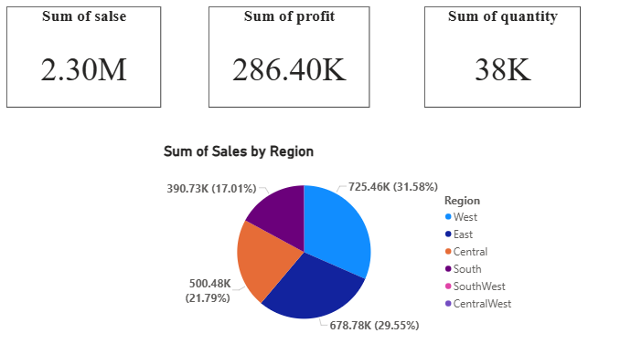

Result:-
Common charts with proper titles, labels, and descriptions were successfully created using
Tableau. The dataset was visualized using different charts with appropriate titles and labels.
Creating charts with titles and labels in Tableau improves data understanding and helps in effective data analysis.

Practical no -07
Title:- Perform sorting and filtering using tableau, create visualizations and publish it on Tableau Cloud.
Aim:- To perform sorting and filtering operations on a dataset using Tableau, create visualizations, and publish them on Tableau Cloud.
Step1:- Prepare the Dataset
1. Load your dataset in a structured format (e.g., Excel, CSV, or a database).
2. Ensure the data is clean and properly formatted with no missing values or inconsistent types.
3. Save the dataset to your local system.
Step 2: Open Tableau Desktop
1. Launch Tableau Desktop on your computer.
2. Click on Connect to Data and choose your data source (Excel, CSV, SQL, etc.).
3. Load the dataset by selecting the file or connecting to the database.
4. Drag and drop the relevant tables into the Canvas if needed.
Step 3: Perform Sorting
1. Create a Sheet: • Navigate to the Sheets tab in Tableau. • Drag a measure (e.g., Sales, Profit) to the Rows shelf and a dimension (e.g., Region, Category) to the Columns shelf.
2. Apply Sorting:
• Hover over the Axis or Header of the visualization (e.g., Category or Region).
• Click the Sort button (ascending or descending order) visible on the axis.
• Alternatively, right-click on the field in the Columns or Rows shelf and select Sort. Choose:
▪ Sort Order: Ascending or Descending. ▪ Sort By: Field (e.g., Profit) or Manual (drag items to reorder manually).

Step 4: Apply Filtering
1. Drag the desired dimension (e.g., Region, Product) to the Filters shelf.
2. A dialog box will appear. Choose the values you want to include or exclude and click OK.
3. To add an interactive filter:
• Right-click on the field in the Filters shelf.
• Select Show Filter to display a filter control on the dashboard or worksheet.
4. Customize the filter display by choosing options like:
• Single Value (Dropdown). • Multi-Value (Checkbox). • Range of Dates or Numbers
Step 5: Create Visualizations
1. Use the Marks Card to change the visualization type (Bar, Line, Pie, etc.).
2. Drag fields to the Columns, Rows, and Marks shelves to build your visualizations.
Examples:
• Bar Chart: Drag a measure (e.g., Sales) to Rows and a dimension (e.g., • Category) to Columns.
• Pie Chart: Select a dimension (e.g., Region) and measure (e.g., Profit) and
• choose the Pie Chart from the Marks dropdown.
• Map: Use geographical fields like Country, State, or City to create maps.
3. Add Colors, Labels, and Tooltips from the Marks card to enhance the visualizations.
Step 6: Build a Dashboard
4. . Click on the Dashboard tab. 3. Drag your sheets onto the dashboard canvas. 4. Customize the layout by resizing and arranging the sheets. 5. Add interactivity using filter actions: • Dashboard > Actions > Add Action > Filter.
Step 7: Publish to Tableau Cloud
1. Ensure you have a Tableau Cloud account. If not, create one at Tableau Cloud.
2. Go to Server > Sign In in Tableau Desktop and log in with your Tableau Cloud credentials
. 3. After signing in: • Click File > Publish to Tableau Cloud.
• Choose the project folder where you want to save the workbook.
• Provide a descriptive name for your workbook.
4. Adjust Permissions and Data Source Settings as needed
. 5. Click Publish to upload the workbook to Tableau Cloud.
Step 8: Share and View Online
1. Log in to your Tableau Cloud account via a web browser.
2. Navigate to the published workbook.
3. Use the share link or invite others by clicking Share and sending invitations.
4. Users can view and interact with your visualizations online
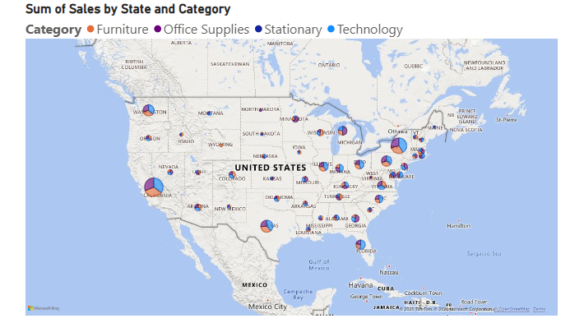

Result:-
Sorted and filtered data was successfully visualized and published on Tableau Cloud. Sorting and filtering operations were performed and visualizations were successfully published online using Tableau Cloud. Tableau provides efficient tools for sorting, filtering, visualization, and online sharing of data through Tableau Cloud.

Practical no 08
Title:- Perform data visualization using Power BI.
Aim:- To perform data visualization on a dataset using Power BI and represent data in graphical form.
Explanation:- Data visualization is the graphical representation of data to understand patterns, trends, and insights. Power BI is a Business Intelligence tool developed by Microsoft that allows users to create interactive reports and dashboards easily.

common Visualizations in Power BI
- Bar Chart
- Line Chart
- Pie Chart
- Table

Opration:-
- Data loading
- Data visualization
- Formatting charts
- Report creation

Process & step:-
• Open Power BI Desktop

• Click on Get Data
- Select data source (Excel / CSV)
- Load the dataset
- Go to Report view
- Select a visualization type
- Drag fields to Axis, Values, and Legend
- Add title and data labels
- Format the visualization
- Save the report
- Bar Chart
- Line Chart
- Pie Chart
- Table
- Bar Chart
- A bar chart is used to compare values across different categories.
- Each bar represents a category and its height shows the value.
- It is useful for comparing quantities like sales, population, or counts.
- Bar charts can be vertical or horizontal.

- 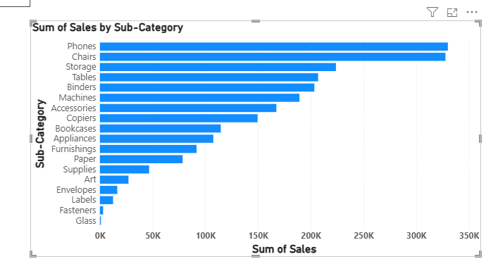
Line Chart
- A line chart shows trends or changes over a period of time.
- Data points are connected by straight lines.
- It is commonly used for time-series data like temperature or stock prices.
- Line charts help identify upward or downward trends.
- 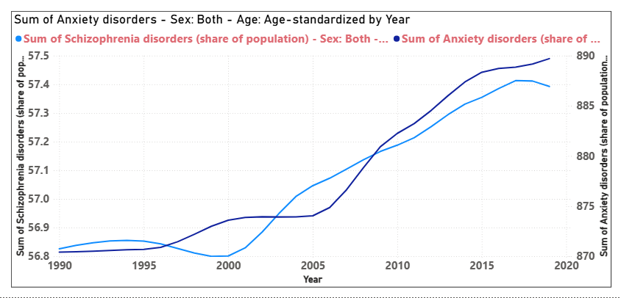
Pie Chart:-
- A pie chart shows the proportion or percentage of parts in a whole.
- The whole pie represents 100%, and each slice shows a category’s share.
- It is best used when the number of categories is small.
- Pie charts make it easy to compare relative sizes visually.

- 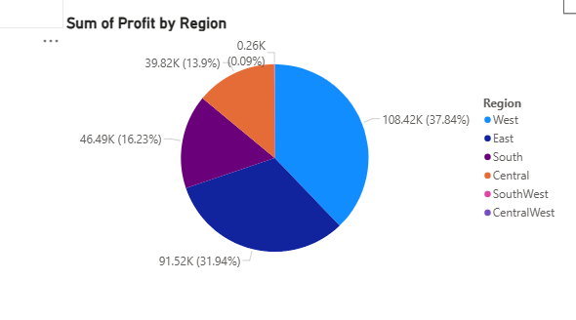
Table:-
- A table displays data in rows and columns.
- It presents exact values in a clear and structured format.
- Tables are useful for detailed data inspection.
- They are often used before creating charts or graphs.
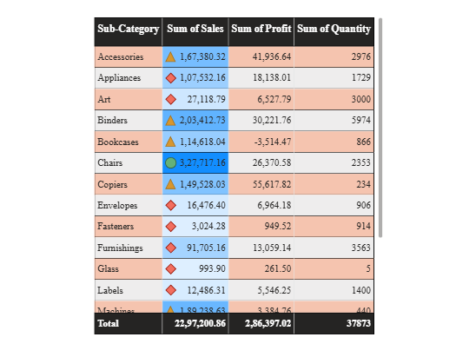

Result:- Data was successfully visualized using different charts in Power BI. The dataset was analyzed and visualized effectively using Power BI. Power BI helps in creating interactive and meaningful visualizations, which support better data analysis and decision making.

Practiacal no -09
Title:- Create reports using Power BI.
Aim:- To create reports using Power BI for effective data analysis and presentation.

Explanation:-
A report in Power BI is a collection of visualizations such as charts, tables, and graphs that represent data in an organized manner. Power BI helps in analyzing data and presenting insights through interactive reports.
Opration perfrom:-
- Data loading
- Report creation
- Data visualization
- Filtering and formatting

Process &step:-
- Open Power BI Desktop
- Click on Get Data and load the dataset
- Clean or transform data if required
- Go to Report view
- Add different visualizations (Bar, Line, Table, Pie)
- Arrange visuals properly on the report page
- Add titles and labels
- Apply filters or slicers
- Save the report

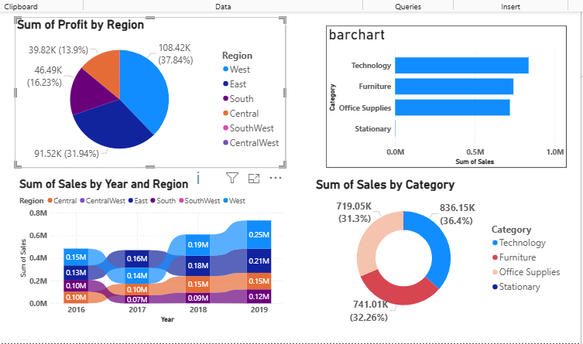

Result:-
A report containing multiple visualizations was successfully created using Power BI. The dataset was analyzed and a report was created to present insights clearly.Power BI enables users to create interactive and informative reports for data analysis and decision making.

.

Practical no -10
Title:- Create a data story in Tableau or power BI.

Aim:- To create a data story using Tableau or Power BI to present data insights in a meaningful and understandable way.

Explanaton:-

Data Story = Dashboard + Insight + Explanation
A data story is a structured way of presenting data insights using visualizations, text, and narration. It helps users understand trends, patterns, and conclusions clearly. Tableau and Power BI provide features to create interactive visual stories using charts and dashboards.

Opration:-

Data visualization
Dashboard creation
Insight explanation
Story presentation

Process& step using BI :-
- Open Power BI Desktop
- Load the dataset
- Create multiple visualizations
- Add text boxes and titles
- Arrange visuals to explain insights
- Apply filters and slicers
- Save the report

VISUALIZATIONS USED
- Bar Chart
- Line Chart
- Pie Chart
- Table

Data story trieling:-
The sales performance dashboard shows that the Technology category has the highest sales among all categories. The West region contributes the maximum profit, indicating strong market demand. Furniture sales are consistent in the East region, showing stable performance. Office Supplies generate lower sales and profit compared to other categories. Overall, the data story helps identify high-performing categories and regions for better business decisions. Power BI helps in creating interactive dashboards and meaningful data stories. By combining multiple visualizations on a single page, it becomes easier to analyze data and derive insights for decision making

Result:-
A data story was successfully created using visualizations and descriptive text Data insights were clearly presented in the form of a data story using Tableau / Power BI. Data storytelling helps in communicating insights effectively and supports better decision making..

